1. A.

B. 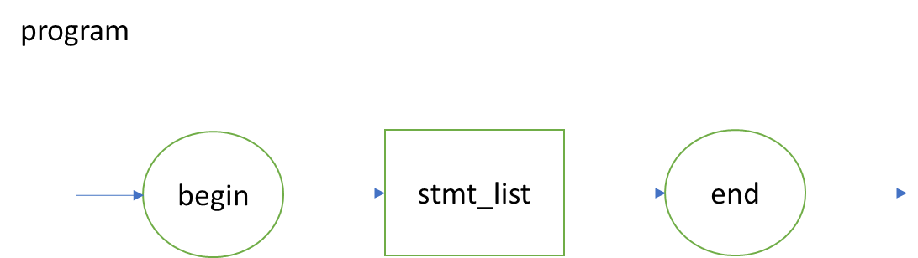

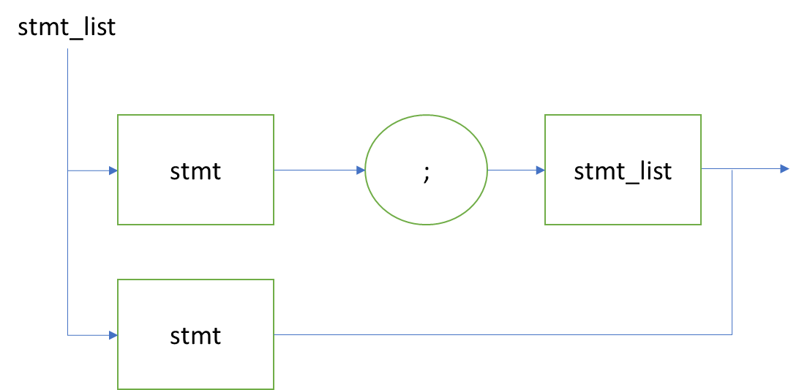

C.

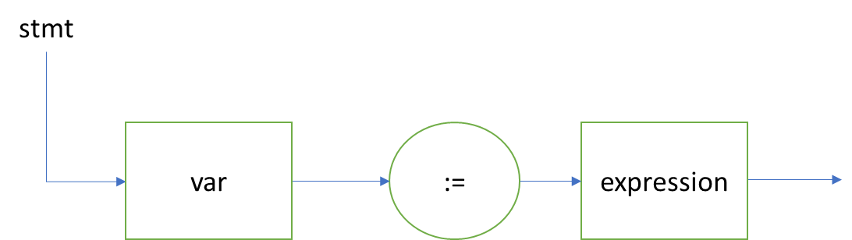

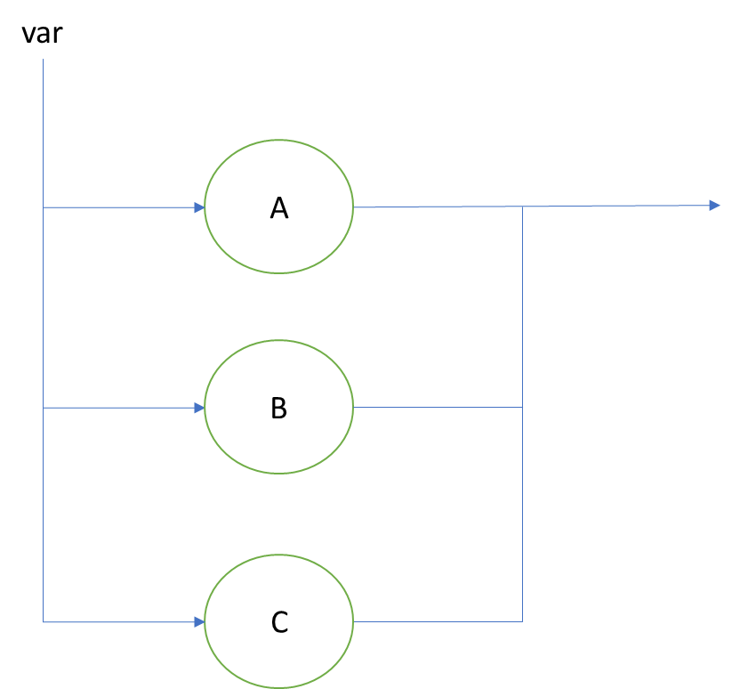D.

E.

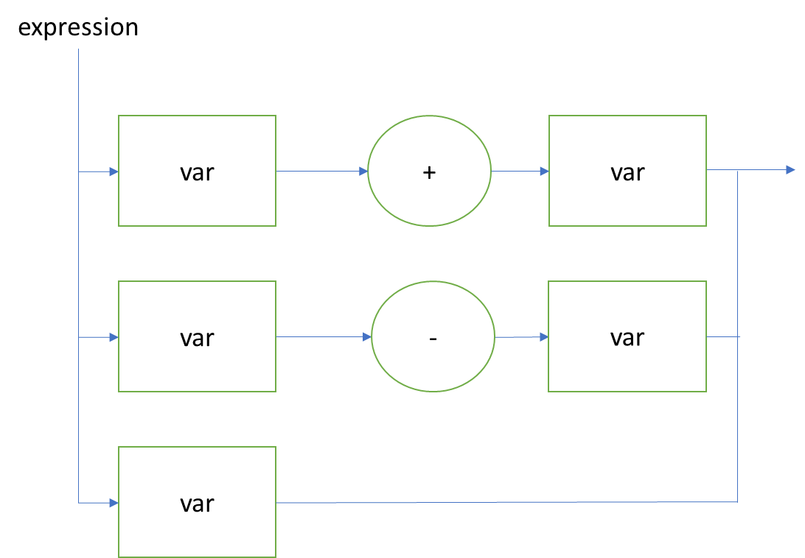

1. Grammar di atas adalah grammar ambigu karena menghasilkan dua parse tree yang berbeda sehingga grammar diubah menjadi grammar berikut.

<assign> ::= <id> := <expr>

<id> ::= A | B | C

<expr> ::= <expr> + <expr> | (<expr>) \* <expr> | (<expr>) | <id>

1. Bahasa yang digunakan adalah JavaScript
2. While

<while> ::= while ( <ekspresi boolean> ) { <kumpulan instruksi> }

<ekspresi boolean> ::= <ekspresi boolean> <operator boolean> <ekspresi boolean> |( <var> <operator boolean> <var>) | <var>

<operator boolean> ::= && | || | < | > | <= | >= | == | !=

<var> ::= <alfanumerik>

<numerik> ::= 0 | 1 | 2 | 3 | 4 | 5 | 6 | 7 | 8 |9 | <numerik><numerik>

<huruf> ::= Q | W | E | R | T | Y | U | I | O | P | A | S | D | F | G | H | J | K | L | Z | X | C | V | B | N | M | q | w | e | r | t | y | u | i | o | p | a | s | d | f | g | h | j | k | l | z | x | c | v | b | n | m | <huruf><huruf>

<alfanumerik> ::= <huruf> | <huruf><alfanumerik> | <numerik><alfanumerik> | <numerik>

1. For

<for> ::= for ( <var> = <var> ; <var> <operasi perbandingan> <var> ; <operasi aritmatik> ) { <kumpulan instruksi> }

<operasi aritmatik> ::= <var>-- | <var>++ | <var>+=<var> | <var>-=<var> | <var>\*=<var> | <var>/=<var>

<operasi perbandingan> ::= < | > | <= | >= | == | !=

<var> ::= <alfanumerik>

<numerik> ::= 0 | 1 | 2 | 3 | 4 | 5 | 6 | 7 | 8 |9 | <numerik><numerik>

<huruf> ::= Q | W | E | R | T | Y | U | I | O | P | A | S | D | F | G | H | J | K | L | Z | X | C | V | B | N | M | q | w | e | r | t | y | u | i | o | p | a | s | d | f | g | h | j | k | l | z | x | c | v | b | n | m | <huruf><huruf>

<alfanumerik> ::= <huruf> | <huruf><alfanumerik> | <numerik><alfanumerik> | <numerik>

1. IF

<if> ::= if ( <ekspresi boolean> ) { <kumpulan instruksi> }

<ekspresi boolean> ::= <ekspresi boolean><operator boolean><ekspresi boolean> |( <var> <operator boolean> <var>) | <var>

<operator boolean> ::= && | || | < | > | <= | >= | == | !=

<var> ::= <alfanumerik>

<numerik> ::= 0 | 1 | 2 | 3 | 4 | 5 | 6 | 7 | 8 |9 | <numerik><numerik>

<huruf> ::= Q | W | E | R | T | Y | U | I | O | P | A | S | D | F | G | H | J | K | L | Z | X | C | V | B | N | M | q | w | e | r | t | y | u | i | o | p | a | s | d | f | g | h | j | k | l | z | x | c | v | b | n | m | <huruf><huruf>

<alfanumerik> ::= <huruf> | <huruf><alfanumerik> | <numerik><alfanumerik> | <numerik>

1. IF ELSE

<if else> ::= if ( <ekspresi boolean> ) { <kumpulan instruksi> } else { <kumpulan instruksi> }

<ekspresi boolean> ::= <ekspresi boolean><operator boolean><ekspresi boolean> |( <var> <operator boolean> <var>) | <var>

<operator boolean> ::= && | || | < | > | <= | >= | == | !=

<var> ::= <alfanumerik>

<numerik> ::= 0 | 1 | 2 | 3 | 4 | 5 | 6 | 7 | 8 |9 | <numerik><numerik>

<huruf> ::= Q | W | E | R | T | Y | U | I | O | P | A | S | D | F | G | H | J | K | L | Z | X | C | V | B | N | M | q | w | e | r | t | y | u | i | o | p | a | s | d | f | g | h | j | k | l | z | x | c | v | b | n | m | <huruf><huruf>

<alfanumerik> ::= <huruf> | <huruf><alfanumerik> | <numerik><alfanumerik> | <numerik>